    Name:  Address:  City/State:  Driver’s License/ID:  Birth Date:  Home #:  Other #:  E-mail:  Occupation:  T-Shirt size:  Have you been contacted by the police in the past year? Yes No  The Nags Head Police Department’s Citizen Academy is not designed to train its participants as a sworn police officer or any other position within this agency. This training is solely for orientation purposes. Applicants are subject to a background check.  Signature:  Date:  Please provide a copy of your valid N.C. driver’s license or a picture ID.  Application | Citizen’s Police Academy  September 28th, 2021 | 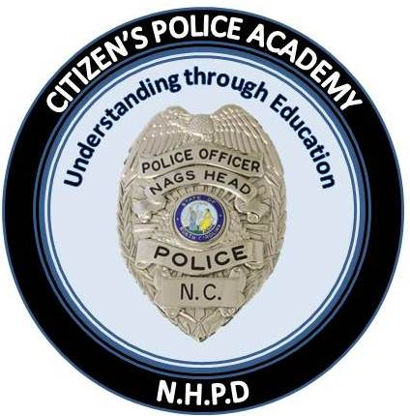
 | Nags Head Police Department  5401 S Croatan Hwy  PO Box 99  Nags Head, NC 27959  www.nagsheadnc.gov  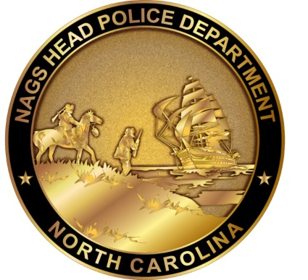 | In Partnership with our Community  Nags Head Police Department  Citizen’s Police Academy

Phone: 252.441.6386
police@nagsheadnc.gov


what is a citizen police academy?  Our Citizen’s Police Academy (CPA) is designed after a traditional police academy curriculum and teaching methods. Our CPA provides members from the community an opportunity to get a better understanding of their police department.  During eight (8) weekly 3-hour sessions, participants are introduced to a variety of legal, community and public safety topics. These topics are designed to orient participants into the police department’s functional and operational procedures. These courses are not intended to train participants as police officers.  The academy is taught by sworn police officers and other legal and field experts. Participants will have the opportunity to meet the Chief of Police and all members of his command staff. Participants are encouraged to ask questions and engage in dialog on police and community related issues.  Our goal is to strengthen our community relationships by giving our citizens an up-close look into the daily operations of their police department and explore the many opportunities where we can band together to create a stronger, safer community.  This FREE program is offered once every year in the fall. Most classes meet Tuesday evenings from 6:00 p.m. to 9:00 p.m. at the Nags Head Police Department. | Class topics  The Citizen’s Police Academy will begin with a welcome from the Chief of Police. Throughout the following eight weeks, participants will have the opportunity for both classroom and hands-on experience in the following law enforcement topics:  Law  Professional Standards  Patrol Officer Procedures  Criminal Investigations  Use of Force Policy  Weapon-less Defense  Firearm Safety  Dispatch Communication  Community Policing  K-9 Demonstrations  Dare County Detention Center Tour  Police Administration  Police Department Building Tour  Crime Scene Scenarios  And More!  CPA graduates are encouraged to participate in the Nags Head Community Watch Association for continued involvement and education. | 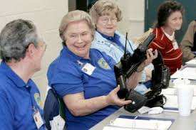  **The Citizen’s Police Academy is a privilege and final admission to the academy is subject to the approval of the Chief of Police or his designee.  Selection procedures  & requirements  There are no physical requirements for most activities and there is no cost to participate.  The qualifications to participate are:  - No prior felony or serious misdemeanor convictions;  - A minimum age of 21 years old.  Priority will be given to residents and business owners of the Town of Nags Head; however everyone is welcome to apply and participate.  Class size is limited to 15 participants per session. Please contact Nags Head Police Department at (252) 441-6386 if you would like an application or have further questions.

